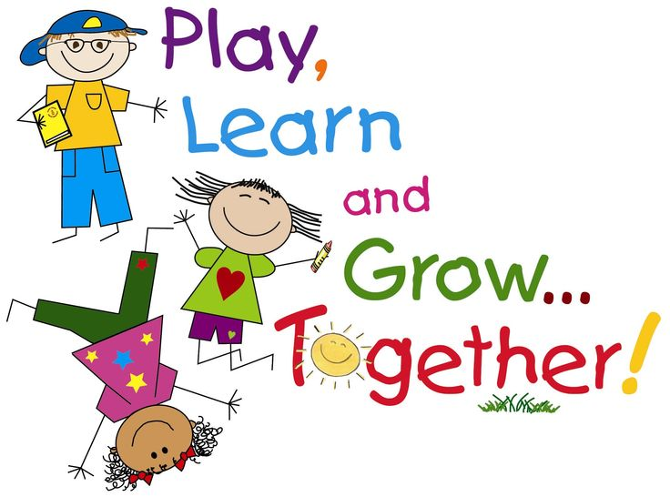

**Colby School Homework Policy**

At Colby School, we encourage children to develop a love of learning and to follow our ethos of “Everyone Learns, Everyone Leads and Everyone Matters.” We do this by providing children with stimulating and fun learning experiences at school, which we hope will inspire them to continue learning at home. We believe family life plays a vital part in a child’s education and that having fun with your family should be valued, appreciated and cherished.

We have **no formal homework** – we encourage children to want to learn outside school and provide them with lots of ideas for how they can do this. We have an expectation that children will read at home and provide children and families with guidance about this, as detailed below:

**Why you should read with your child every day**

We want to encourage and foster a love of reading in the children at our school. As parents, we know that you want the very best for your children and already appreciate that learning to read is key to accessing the curriculum at school and the wider world. However, with increasingly busy lives it may seem that hearing a child read at the end of a tiring day can feel like just another chore. We hope that by writing this article for the newsletter we can remind everyone of the importance of reading with children, not just as a mechanical process but as an enjoyable activity for you to share with your children. You reading to your child is equally as important as them listening to you.

Here are some reasons why you should read with your child every day:

1. Reading is fun! Sharing a story, or a non-fiction book, whether it is read by an adult or by a child can give you the opportunity to share funny moments, or wonder at the world and beyond.
2. The value of a bedtime story cannot be over-estimated. It can be a quiet, settling time and gives your child the opportunity to listen to story language and allow their imagination to paint pictures. A CD or DVD just doesn’t have the same impact as time with a family member.
3. Children absorb language structure and extend their vocabulary.
4. Children are able to think more logically and express their own thoughts and ideas more clearly.
5. Attention and concentration span is improved which has an impact on all learning.

It is really useful to spend a few moments discussing a book with your child. You can find out how much they have enjoyed it, how well they understood it and whether they have any questions about it.

Some useful questions to ask your child about the book they have shared - choose just one or two to discuss.

1. Who are the main characters?
2. What do you think will happen next?
3. How do you think that character feels? Why? How would you feel in that situation?
4. Can you predict how the book will end?
5. Who is your favourite character? Why?
6. Is there a hidden message in the story? What is it?
7. Can you tell the story in your own words?
8. Do you like how it ended? Can you think of another way the book could have ended?

Remember that reading doesn’t just have to be ‘done’ through books. Comics and magazines are equally good at encouraging children’s interest. Point out signposts and information as you are out and about. Children like to be like you, so let them see you reading newspapers, magazines, as well as books.

We hold regular reading competitions and events to encourage children to find an author to suit them or to try something new. Children play a major role in choosing books for the school library.

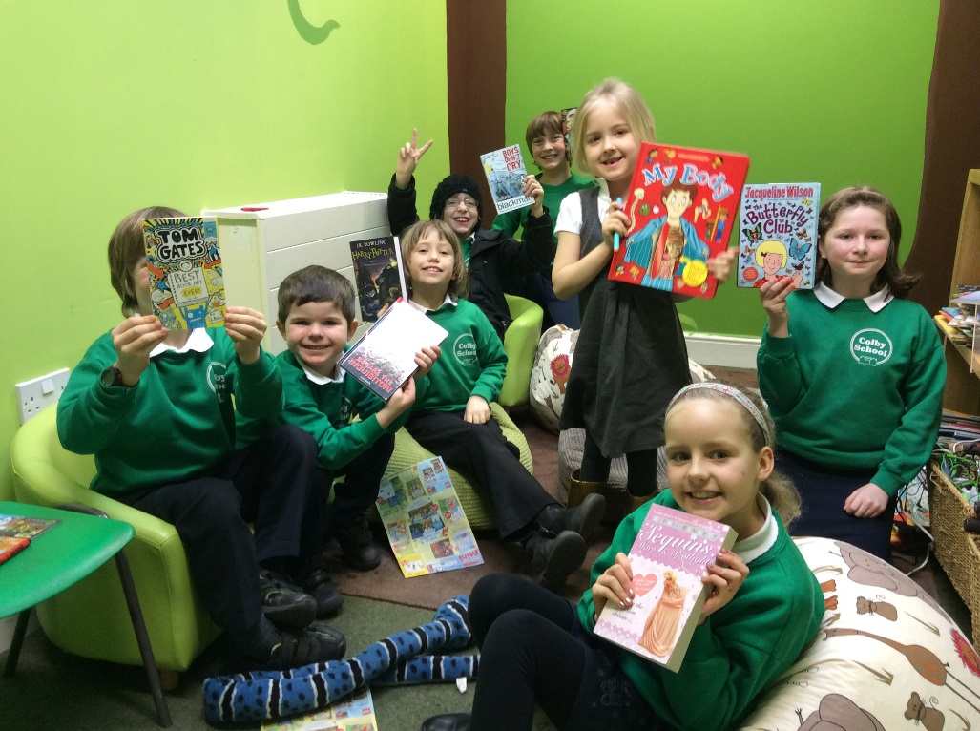

**Books, books, books!**

All the new books selected by the winners of Mr Brown’s Reading Challenge are now available in the library. Our library is absolutely full of loads of lovely new books.

**Every class teacher provides children with ideas for optional homework:**

**Amber Class**

Reception children are given Jolly Phonic Worksheets to complete at home and are expected to read every day.

Year 1 children are expected to read every day, have weekly spellings to learn at home and have access to the LEXIA programme for optional extra work.

Children who have Communication Passports have extra support worksheets sent home related to their targets. This additional work is discussed with parents at Communication Passport meetings.

**Sapphire Class**

Year 1 children are expected to read every day, have weekly spellings to learn at home (given out on Friday) and have access to the LEXIA programme for optional extra work.

Year 2 children are expected to read every day, have weekly spellings to learn at home (given out on a Friday) and have a weekly A4 worksheet of literacy or mathematics to help with their preparation for the Year 2 National Tests.

Individual homework may be given focussing on personal targets, such as handwriting.

**Emerald Class**

Children are expected to read lots at home and also to practice times tables. Parents are given detailed information about how they can help with place value work and number bonds, for children who require additional support in mathematics.

Children are encouraged to do Sumdog at home and have regular class competitions to compete in.

Children are given optional one off homework projects. For example, covering a parent in sticky notes to label their bones and muscles or growing cress in an egg shell at home.

Children are encouraged to bring in any work they do at home and can earn Headteacher Awards or Magic Suitcase prizes.

Year 4 children have Mathematics’ books to complete at home, if they choose to.

**Ruby Class**

Children are expected to:

Read daily.

Practice spellings for a test each week.

Practice time tables and telling the time.

Children also have access to IXL and Sumdog for optional mathematics and to LEXIA for optional reading and spelling work.

**Amethyst Class**

Year 6 children are allocated Grammar, Spelling and Punctuation books and Mathematics’ books. Year 5 children can choose to participate.

An after school Mathematics’ Club is available for Year 6 children and this counts as their homework time.

Children are encouraged to read as much as possible.

Year 6 children are also expected to organise well-prepared presentations in their own time and complete tasks related to their leadership responsibilities as required.

MC900251743[1]

**Outdoor Learning**

We love Outdoor Learning at Colby and throughout the Spring term 2017 we will use the National Trust’s “50 things to do before you are 11 ¾” to help children plan and complete their own outdoor learning targets.

We hope families may decide to have a go at some of these things at home. Have fun!

**Adventurer Discoverer**

1 Climb a tree 11 Go on a really long bike ride

2 Roll down a really big hill 12 Make a trail with sticks

3 Camp out in the wild 13 Make a mud pie

4 Build a den 14 Dam a stream

5 Skim a stone 15 Play in the snow

6 Run around in the rain 16 Make a daisy chain

7 Fly a kite 17 Set up a snail race

8 Catch a fish with a net 18 Create some wild art

9 Eat an apple straight from a tree 19 Play pooh sticks

10 Play conkers 20 Jump over waves

**Ranger Tracker**

21 Pick blackberries growing in the wild 31 Hunt for bugs

22 Explore inside a tree 32 Find some frogspawn

23 Visit a farm 33 Catch a falling leaf

24 Go on a walk barefoot 34 Track wild animals

25 Make a grass trumpet 35 Discover what’s in a pond

26 Hunt for fossils and bones 36 Make a home for a wild animal

27 Go star gazing 37 Check out the crazy creatures in a rock pool

28 Climb a huge hill 38 Bring up a butterfly

29 Explore a cave 39 Catch a crab

30 Hold a scary beast 40 Go on a nature walk at night

**Explorer**

41 Plant it, grow it, eat it

42 Go swimming in the sea

43 Build a raft

44 Go bird watching

45 Find your way with a map and compass

46 Try rock climbing

47 Cook on a campfire

48 Learn to ride a horse

49 Find a geocache

50 Canoe down a river

Children are encouraged to bring any projects they complete at home into school for us to celebrate their learning. They receive house points, Headteacher Awards and other treats / prizes for exceptional work.

Children are also encouraged to take part in a variety of extra-curricular clubs, including sport and music.

The Friends of Colby School often sponsor and promote homework challenges.

Perhaps the most important homework of all is the homework given to our Year 6 children, the weekend before their National Tests:



**Weekend Homework**

Every one may wish to complete the homework set for

Year 6 this weekend – I’m definitely going to!

Please make sure you spend the whole weekend doing homework. You should select your homework tasks from the following list of activities.

Complete as much homework as possible and follow the instructions carefully!

MCj01358230000[1]

MCj03835920000[1]HOMEWORK:

Play with your friends

Enjoy the lovely weather

Be energetic

Spend time having a laugh

Watch lots of TV on the sofa

Listen to your favourite music

Do the things you most like to do

Make sure you RELAX and have FUN!

Remember to get plenty of rest and we’ll see you on Monday.

Christine Mead